VIETNAM NATIONAL UNIVERSITY, HO CHI MINH CITY
UNIVERSITY OF SCIENCE
FACULTY OF INFORMATION TECHNOLOGUY


PROJECT PROGRESS REPORT

LECTURE: | TS. Lê Ngọc Thành  ThS. Phạm Trọng Nghĩa  CN. Lê Nhựt Nam
STUDENTS: | Lý Liên Hoa – 22127117  Lê Thị Ngọc Linh – 22127232  Nguyễn Đặng Hoàng Dinh – 22127069  Hoàng Duy Hưng - 22127139

TP. Hồ Chí Minh – 2024
Contents
1. PROJECT OVERVIEW 2
2. PROGRESS 3
2.1. Current status 3
2.2. Current issues 4
2.3. Ideas to solve these issues 4
3. PLAN FOR REMAIN TIME TO COMPLETE THE PROJECT 5

- PROJECT OVERVIEW
Our project focuses on collecting and analyzing data from Long Chau Pharmacy about functional foods and cosmetics to not only help customers find suitable pharmaceutical products but also provide insight to businesses about market trends and customer preferences. Attributes like product name, brand origin, price, category, and reviews may help our team to answer questions about what influences purchasing decisions, and the best-selling products.

- PROGRESS
  - Current status
We were successful in Collecting data from Long Chau Pharmacy about functional foods and cosmetics by using Selenium tools and requires library. After this phase, we begin Processing data and found that there were many non-values in our raw data, especially in users’ review features. We decided to choose deleting the rows having non-values, because the number of samples of the data set is still above the allowable limit, from 2454 to 1102 samples. The poor data analysis has adversely affected the process of Making questions. Because formulating questions is still challenging, Visualization is also affected. We are now in “Asking meaningful questions” phase and preparing to move to building model stage.
List of questions and reasons for choosing:
Question 1: In each cosmetic and dietary supplement category, which country's products have the highest sales prices and ratings, and how does this indicate supply trends? And vice versa?
- Reason: Identifying countries with high-priced products and best reviews helps understand supply trends and international source quality.
Question 2: Product categories with general functions are produced on many continents? Which famous brands are associated with the leading countries in the continent?
- Reason: Analyzing famous brands from leading countries helps understand cross-functional product distribution and brand influence by continent.
Question 3: In each cosmetic and dietary supplement category, which countries have the highest market share, and how does this indicate supply trends?
- Reason: Countries with high market shares reflect each country's competitiveness and product supply trends.
Question 4: Which format is more popular and easier to use according to category?
- Reason: Popular formats help analyze preference and convenience across product categories.
Question 5: Price distribution of products of famous brands
- Reason: Price distribution analysis helps understand market stratification and pricing strategies of famous brands.

  - Current issues
After gaining more knowledge from the lectures, we realized that the raw dataset we collected to conducting preliminary processing, we encountered some problems as follows:
- Missing data: During the data cleaning process, we removed rows containing many null values. This results in a reduction of the original number of data lines by a little more than 50% (specifically about 55.09%), which significantly affects the scale of data for analysis.
- Limited data scope: The features in the current data collected from the Long Chau pharmacy website have certain limitations because it is not enough to answer more complex questions (for example, number of products sold, demand by market). This makes asking analytical questions difficult.
- Data quality: The dataset lacks key attributes, limiting the ability to identify trends or make comparisons. Although there are 7 columns, some of the values in these columns do not really help with analytical work or formulating questions.
Ex: The “Rating” column has values ranging only from 4.5 to 5, with many duplicates within the 0 to 5 scale. Similarly, the “Category” column has too many distinct values, many of which are duplicated, making it difficult to categorize them.
à This is an example of how our group wanted to combine the columns “Brand Origin” and “Rating” to better understand whether there is any correlation between different “Brand Origin” and “Rating”. After visualizing it, we did not observe much difference because the data in the 'Rating' column lacked diversity.
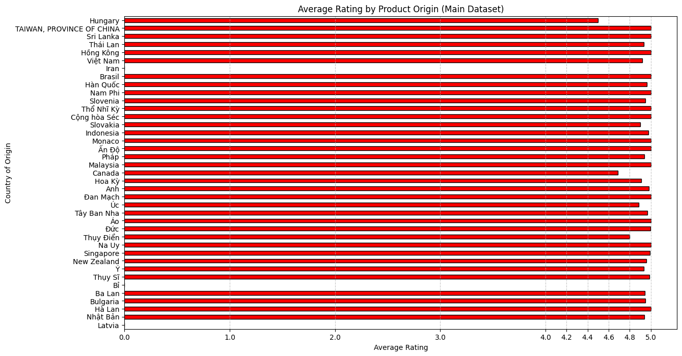

  - Ideas to solve these issues
For each issue mentioned above, the solution method for each problem is outlined below
- Revisiting Data Processing Steps: Improve data cleaning process to make them more efficient and attempt to fill missing values using estimation methods if possible. For more specific:
Instead of handling rows with NULL values by deleting them as we did, which removed more than 40% of the potential samples, we decided to explore the data again.
  - Step 1: Check the percentage of NULL values in each column.
  - Step 2: Delete any column if the missing values exceed 75%.
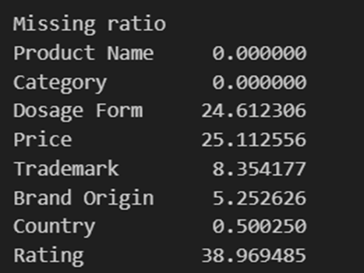

  - Step 3: For numeric data types, fill NULL values using the median. For non-numeric data types, replace NULL values with the most frequent value in that column.
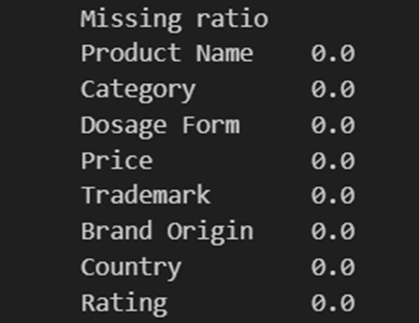

- Expand data source: Collect additional data from other websites to get additional required properties (for example, number of products sold of Pharmacity website).
- Increasing the number of attributes: To increase the number of possible questions from the available data and decrease the difficulties when making questions, we decided to create additional attributes. The new attribute columns will be derived from existing columns. This helps reduce the 45 different country values to just 5 values: Asia, Europe, Africa, America, Others.
  - The “Continent” column will be derived from the “Country” column.
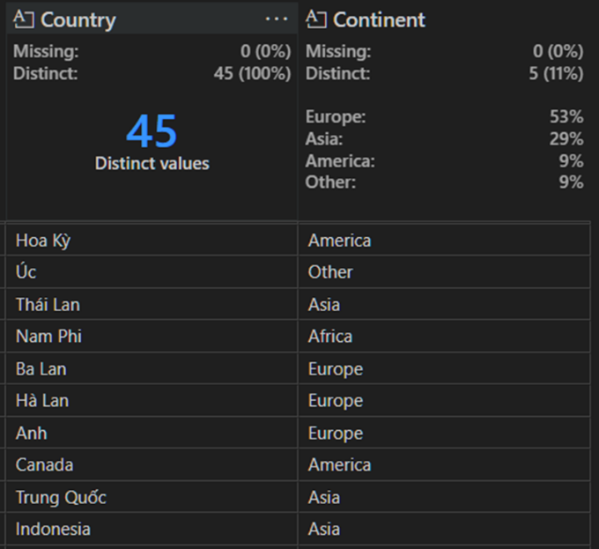
- The initial “Category” column had too many different values, so we realized we could group similar categories together. From 94 different categories, we combined them into 16 different values in a new column called “General_function”.
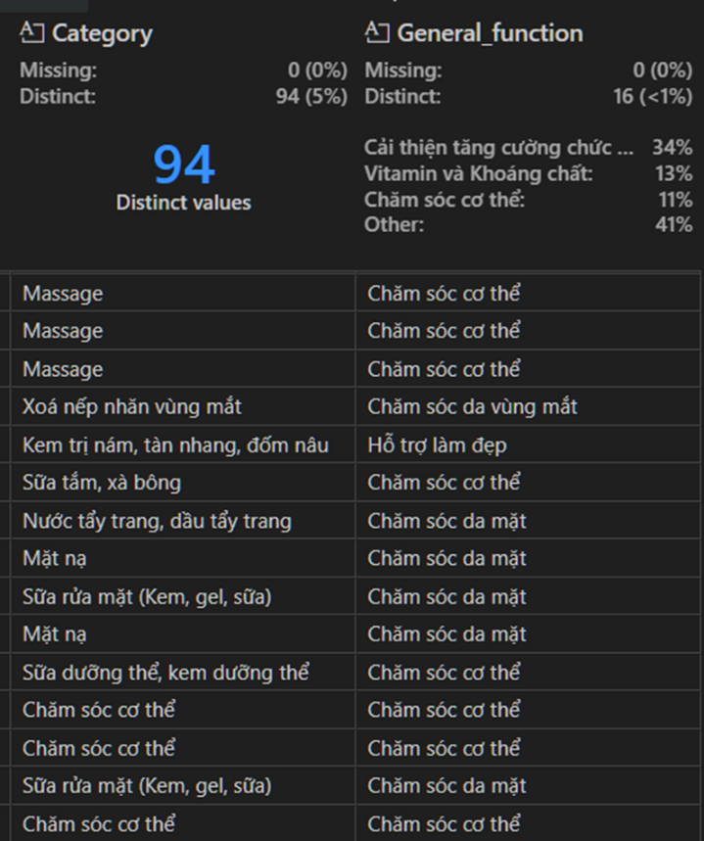
    - Having two new columns of data derived from the original two columns helps us have a more comprehensive and clear view of the data. When the original columns contain too many distinct values, it directly impacts both formulating questions and visualizing. Grouping samples with common attributes into a single group is our group's approach to this issue

- Adjust the scope of the question: Develop analytical questions that are more appropriate to the scope of the current data, focusing on the information the data can support.

- PLAN FOR REMAIN TIME TO COMPLETE THE PROJECT
Our team is still trying to be on track with our original plan. So far, although we are having difficulty with the lack of data to be able to form meaningful questions, we have still ensured the minimum requirements set by the lecturer. We will continue to proceed with the project with the next stages based on the collected data set, at the same time, exploiting new data information from other websites to try to overcome the problems mentioned above.
Here is our plan for the remaining time (if we don’t need to collect data again), we will parallelize the model building process and improve the data processing step:

STT | Task | Estimated time | Person in charge
1 | Data analysis/ making meaningful questions | November 11th, 2024 → November 17th, 2024 | Lý Liên Hoa  Lê Thị Ngọc Linh
2 | Build again cleaning process | November 18th , 2024 → November 28th, 2024 | Nguyễn Đặng Hoàng Dinh  Hoàng Duy Hưng
3 | Build and evaluate models | November 18th , 2024 → December 2nd , 2024 | Lý Liên Hoa  Lê Thị Ngọc Linh
4 | Final presentation tasks | December 2nd , 2024 →December 4th , 2024 | Lý Liên Hoa  Lê Thị Ngọc Linh  Nguyễn Đặng Hoàng Dinh  Hoàng Duy Hưng
5 | Summary | December 4th , 2024 → December 5th , 2024 | Lý Liên Hoa

